UNITED STATES
SECURITIES AND EXCHANGE COMMISSION
Washington, D.C. 20549

SCHEDULE 14A
Proxy Statement Pursuant to Section 14(a) of the
Securities Exchange Act of 1934
(Amendment No.)

Filed by the Registrant ☒
Filed by a Party other than the Registrant ☐
Check the appropriate box:

☐ | Preliminary Proxy Statement

☐ | Confidential, for Use of the Commission Only (as permitted by Rule 14a-6(e)(2))

☐ | Definitive Proxy Statement

☒ | Definitive Additional Materials

☐ | Soliciting Material under §240.14a-12
Honeywell International Inc.
(Name of Registrant as Specified In Its Charter)
(Name of Person(s) Filing Proxy Statement, if other than the Registrant)
Payment of Filing Fee (Check all boxes that apply):

☒ | No fee required

☐ | Fee paid previously with preliminary materials

☐ | Fee computed on table in exhibit required by Item 25(b) per Exchange Act Rules 14a-6(i)(1) and 0-11


2026 Annual Meeting Shareowner Engagement April / May 2026


1 AGenda PORTFOLIO TRANSFORMATION | p. 2 2026 ANNUAL MEETING: VOTING MATTERS | p. 5 APPENDIX | p. 15 FORWARD LOOKING STATEMENTS We describe many of the trends and other factors that drive our business and future results in this presentation. Such discussions contain forward-looking statements within the meaning of Section 21E of the Securities Exchange Act of 1934, as amended (the Exchange Act), including statements related to the proposed separation of Honeywell and Honeywell Aerospace and the planned sales of the Productivity Solutions and Services and Warehouse and Workflow Solutions businesses. Forward-looking statements are those that address activities, events, or developments that we or our management intend, expect, project, believe, or anticipate will or may occur in the future. They are based on management’s assumptions and assessments in light of past experience and trends, current economic and industry conditions, expected future developments, and other relevant factors, many of which are difficult to predict and outside of our control, including Honeywell's current expectations, estimates, and projections regarding the proposed separation of Honeywell and Honeywell Aerospace and the planned sales of the Productivity Solutions and Services and Warehouse and Workflow Solutions businesses. They are not guarantees of future performance, and actual results, developments, and business decisions may differ significantly from those envisaged by our forward-looking statements, including the proposed separation of Automation and Aerospace Technologies and the planned sales of the Productivity Solutions and Services and Warehouse and Workflow Solutions businesses, and the anticipated benefits of each. We do not undertake to update or revise any of our forward-looking statements, except as required by applicable securities law. Our forward-looking statements are also subject to material risks and uncertainties, including ongoing macroeconomic and geopolitical risks, such as changes in or application of trade and tax laws and policies, including the impacts of tariffs and other trade barriers and restrictions, lower GDP growth or recession in the U.S. or globally, supply chain disruptions, capital markets volatility, inflation, and certain regional conflicts, including ongoing conflicts in the Middle East, which can affect our performance in both the near- and long-term. In addition, no assurance can be given that any plan, initiative, projection, goal, commitment, expectation, or prospect set forth in this presentation can or will be achieved. These forward-looking statements should be considered in light of the information included in this presentation, our Form 10-K and other filings with the Securities and Exchange Commission. Any forward-looking plans described herein are not final and may be modified or abandoned at any time. 2026 Annual Meeting – Shareowner Engagement


UPDATES ON OUR PORTFOLIO transformation 2026 Annual Meeting – Shareowner Engagement

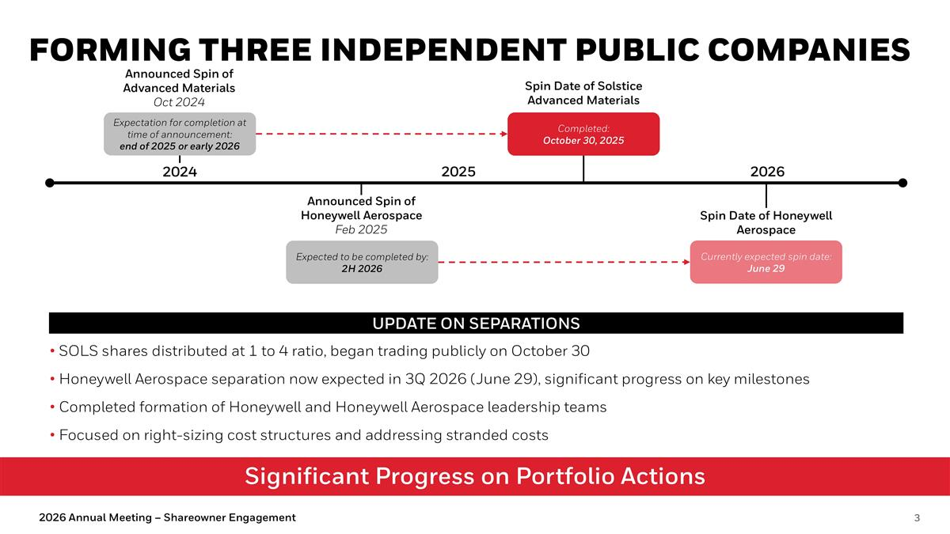
Significant Progress on Portfolio Actions Forming Three Independent Public Companies Announced Spin of Advanced Materials Oct 2024 Expectation for completion at time of announcement: end of 2025 or early 2026 Announced Spin of Honeywell Aerospace Feb 2025 Expected to be completed by: 2H 2026 Spin Date of Solstice Advanced Materials Completed: October 30, 2025 2024 2025 2026 Spin Date of Honeywell Aerospace Currently expected spin date: June 29 UPDATE ON SEPARATIONS SOLS shares distributed at 1 to 4 ratio, began trading publicly on October 30 Honeywell Aerospace separation now expected in 3Q 2026 (June 29), significant progress on key milestones Completed formation of Honeywell and Honeywell Aerospace leadership teams Focused on right-sizing cost structures and addressing stranded costs 2026 Annual Meeting – Shareowner Engagement

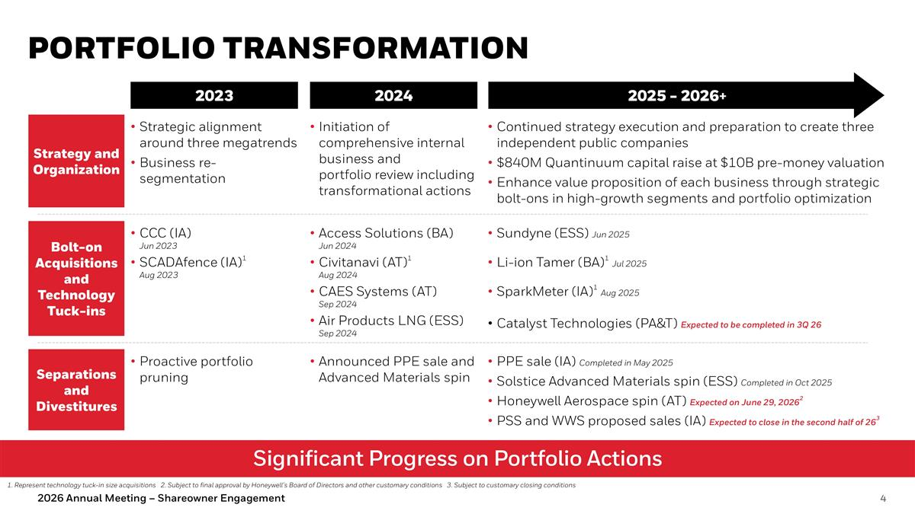
Portfolio Transformation Significant Progress on Portfolio Actions 2023 2024 2025 - 2026+ Strategy and Organization Bolt-on Acquisitions and Technology Tuck-ins Strategic alignment around three megatrends Business re-segmentation Continued strategy execution and preparation to create three independent public companies $840M Quantinuum capital raise at $10B pre-money valuation Enhance value proposition of each business through strategic bolt-ons in high-growth segments and portfolio optimization Access Solutions (BA) Jun 2024 Civitanavi (AT)1 Aug 2024 CAES Systems (AT) Sep 2024 Air Products LNG (ESS) Sep 2024 CCC (IA) Jun 2023 SCADAfence (IA)1 Aug 2023 Initiation of comprehensive internal business and portfolio review including transformational actions Announced PPE sale and Advanced Materials spin PPE sale (IA) Completed in May 2025 Solstice Advanced Materials spin (ESS) Completed in Oct 2025 Honeywell Aerospace spin (AT) Expected on June 29, 20262 PSS and WWS proposed sales (IA) Expected to close in the second half of 263 Separations and Divestitures Proactive portfolio pruning 1. Represent technology tuck-in size acquisitions 2. Subject to final approval by Honeywell’s Board of Directors and other customary conditions 3. Subject to customary closing conditions Sundyne (ESS) Jun 2025 Li-ion Tamer (BA)1 Jul 2025 SparkMeter (IA)1 Aug 2025 Catalyst Technologies (PA&T) Expected to be completed in 3Q 26 2026 Annual Meeting – Shareowner Engagement


2026 Annual Meeting Of Shareowners VOTING MATTERS 2026 Annual Meeting – Shareowner Engagement

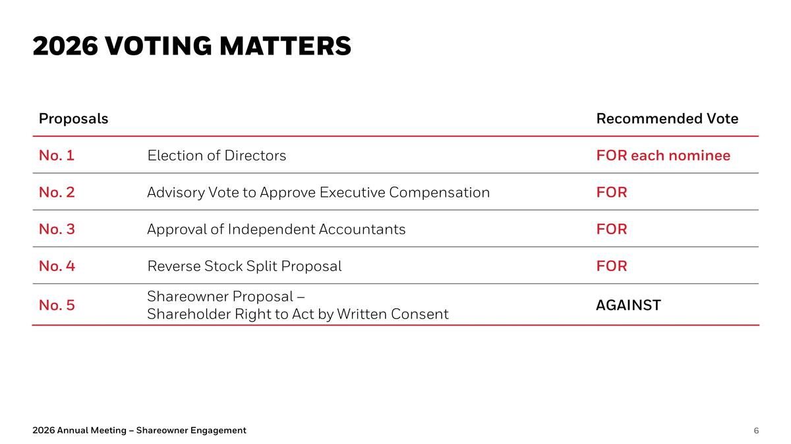
2026 Voting Matters 2026 Annual Meeting – Shareowner Engagement Proposals Recommended Vote No. 1 Election of Directors FOR each nominee No. 2 Advisory Vote to Approve Executive Compensation FOR No. 3 Approval of Independent Accountants FOR No. 4 Reverse Stock Split Proposal FOR No. 5 Shareowner Proposal – Shareholder Right to Act by Written Consent AGAINST

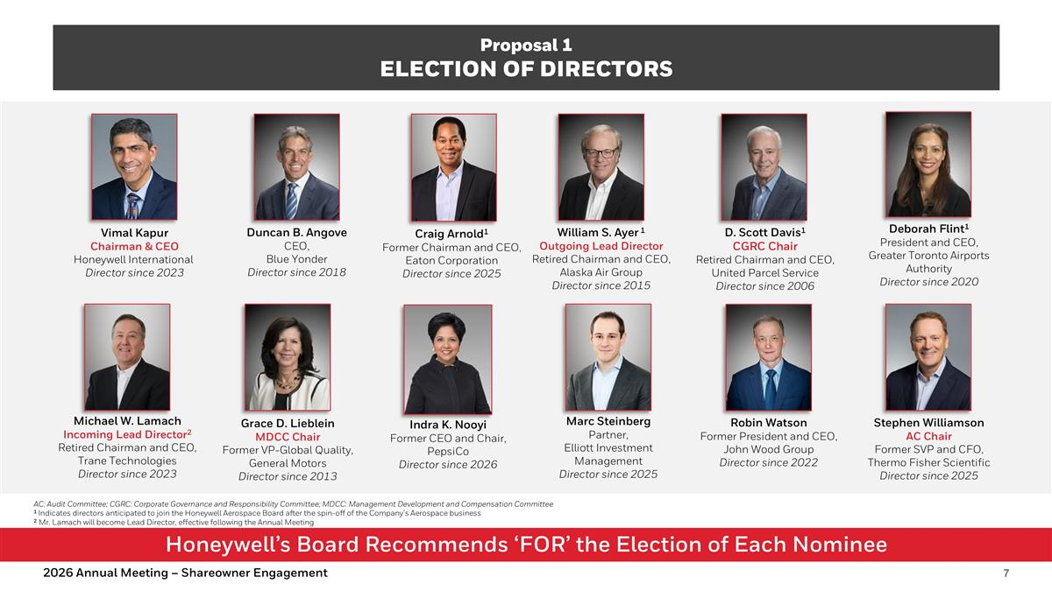
Honeywell’s Board Recommends ‘FOR’ the Election of Each Nominee Proposal 1 Election of Directors AC: Audit Committee; CGRC: Corporate Governance and Responsibility Committee; MDCC: Management Development and Compensation Committee 1 Indicates directors anticipated to join the Honeywell Aerospace Board after the spin-off of the Company’s Aerospace business 2 Mr. Lamach will become Lead Director, effective following the Annual Meeting D. Scott Davis1 CGRC Chair Retired Chairman and CEO, United Parcel Service Director since 2006 Duncan B. Angove CEO, Blue Yonder Director since 2018 William S. Ayer 1 Outgoing Lead Director Retired Chairman and CEO, Alaska Air Group Director since 2015 Vimal Kapur Chairman & CEO Honeywell International Director since 2023 Grace D. Lieblein MDCC Chair Former VP-Global Quality, General Motors Director since 2013 Robin Watson Former President and CEO, John Wood Group Director since 2022 Michael W. Lamach Incoming Lead Director2 Retired Chairman and CEO, Trane Technologies Director since 2023 Deborah Flint1 President and CEO, Greater Toronto Airports Authority Director since 2020 Stephen Williamson AC Chair Former SVP and CFO, Thermo Fisher Scientific Director since 2025 Marc Steinberg Partner, Elliott Investment Management Director since 2025 Indra K. Nooyi Former CEO and Chair, PepsiCo Director since 2026 Craig Arnold1 Former Chairman and CEO, Eaton Corporation Director since 2025 2026 Annual Meeting – Shareowner Engagement

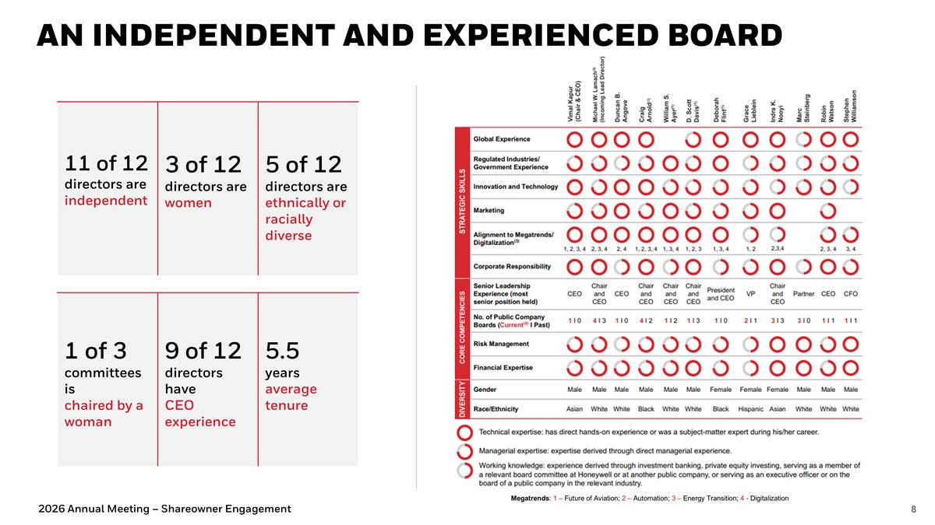
An Independent and Experienced BOARD 1 of 3 committees is chaired by a woman 9 of 12 directors have CEO experience 5.5 years average tenure 11 of 12 directors are independent 3 of 12 directors are women 5 of 12 directors are ethnically or racially diverse Megatrends: 1 – Future of Aviation; 2 – Automation; 3 – Energy Transition; 4 - Digitalization 2026 Annual Meeting – Shareowner Engagement

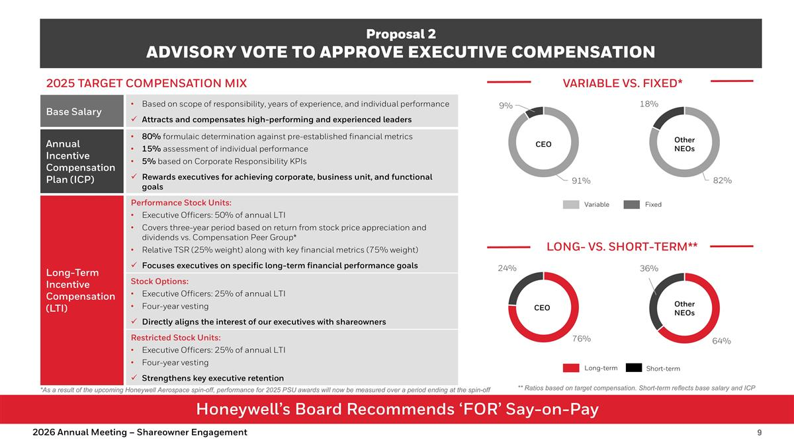
Honeywell’s Board Recommends ‘FOR’ Say-on-Pay Proposal 2 Advisory Vote to Approve Executive Compensation Base Salary Based on scope of responsibility, years of experience, and individual performance Attracts and compensates high-performing and experienced leaders Annual Incentive Compensation Plan (ICP) 80% formulaic determination against pre-established financial metrics 15% assessment of individual performance 5% based on Corporate Responsibility KPIs Rewards executives for achieving corporate, business unit, and functional goals Long-Term Incentive Compensation (LTI) Performance Stock Units: Executive Officers: 50% of annual LTI Covers three-year period based on return from stock price appreciation and dividends vs. Compensation Peer Group* Relative TSR (25% weight) along with key financial metrics (75% weight) Focuses executives on specific long-term financial performance goals Stock Options: Executive Officers: 25% of annual LTI Four-year vesting Directly aligns the interest of our executives with shareowners Restricted Stock Units: Executive Officers: 25% of annual LTI Four-year vesting Strengthens key executive retention Variable vs. Fixed* Long- vs. Short-Term** Variable Fixed Long-term Short-term ** Ratios based on target compensation. Short-term reflects base salary and ICP CEO 2026 Annual Meeting – Shareowner Engagement Other NEOs CEO Other NEOs 2025 Target Compensation mix *As a result of the upcoming Honeywell Aerospace spin-off, performance for 2025 PSU awards will now be measured over a period ending at the spin-off

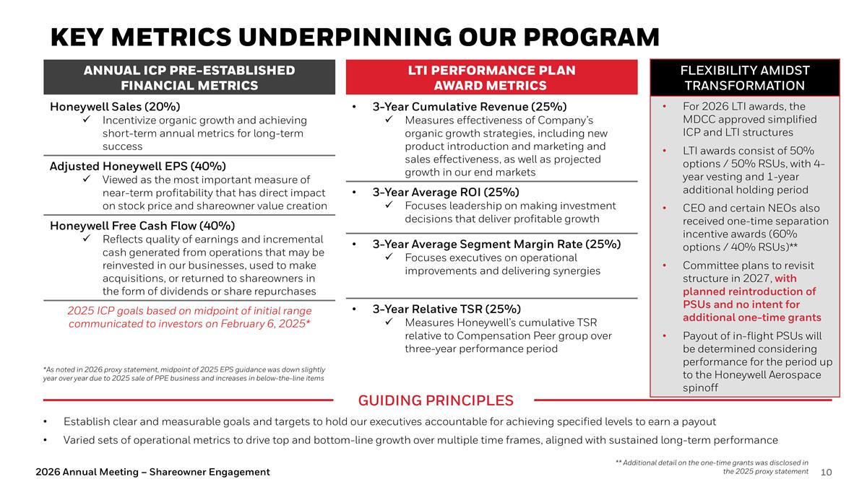
KEY METRICS UNDERPINNING OUR PROGRAM LTI Performance Plan Award Metrics 3-Year Cumulative Revenue (25%) Measures effectiveness of Company’s organic growth strategies, including new product introduction and marketing and sales effectiveness, as well as projected growth in our end markets 3-Year Average ROI (25%) Focuses leadership on making investment decisions that deliver profitable growth 3-Year Average Segment Margin Rate (25%) Focuses executives on operational improvements and delivering synergies 3-Year Relative TSR (25%) Measures Honeywell’s cumulative TSR relative to Compensation Peer group over three-year performance period Annual ICP Pre-established Financial Metrics Honeywell Sales (20%) Incentivize organic growth and achieving short-term annual metrics for long-term success Adjusted Honeywell EPS (40%) Viewed as the most important measure of near-term profitability that has direct impact on stock price and shareowner value creation Honeywell Free Cash Flow (40%) Reflects quality of earnings and incremental cash generated from operations that may be reinvested in our businesses, used to make acquisitions, or returned to shareowners in the form of dividends or share repurchases 2025 ICP goals based on midpoint of initial range communicated to investors on February 6, 2025* Establish clear and measurable goals and targets to hold our executives accountable for achieving specified levels to earn a payout Varied sets of operational metrics to drive top and bottom-line growth over multiple time frames, aligned with sustained long-term performance Guiding Principles Flexibility Amidst Transformation For 2026 LTI awards, the MDCC approved simplified ICP and LTI structures LTI awards consist of 50% options / 50% RSUs, with 4-year vesting and 1-year additional holding period CEO and certain NEOs also received one-time separation incentive awards (60% options / 40% RSUs)** Committee plans to revisit structure in 2027, with planned reintroduction of PSUs and no intent for additional one-time grants Payout of in-flight PSUs will be determined considering performance for the period up to the Honeywell Aerospace spinoff ** Additional detail on the one-time grants was disclosed in the 2025 proxy statement 2026 Annual Meeting – Shareowner Engagement *As noted in 2026 proxy statement, midpoint of 2025 EPS guidance was down slightly year over year due to 2025 sale of PPE business and increases in below-the-line items

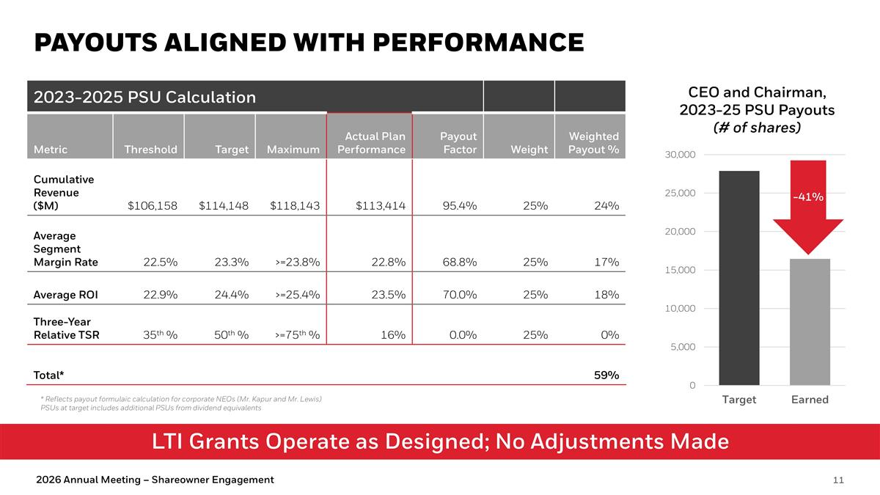
LTI Grants Operate as Designed; No Adjustments Made Payouts Aligned with Performance 2026 Annual Meeting – Shareowner Engagement 2023-2025 PSU Calculation Metric Threshold Target Maximum Actual Plan Performance Payout Factor Weight Weighted Payout % Cumulative Revenue ($M) $106,158 $114,148 $118,143 $113,414 95.4% 25% 24% Average Segment Margin Rate 22.5% 23.3% >=23.8% 22.8% 68.8% 25% 17% Average ROI 22.9% 24.4% >=25.4% 23.5% 70.0% 25% 18% Three-Year Relative TSR 35th % 50th % >=75th % 16% 0.0% 25% 0% Total* 59% CEO and Chairman, 2023-25 PSU Payouts (# of shares) -41% * Reflects payout formulaic calculation for corporate NEOs (Mr. Kapur and Mr. Lewis) PSUs at target includes additional PSUs from dividend equivalents

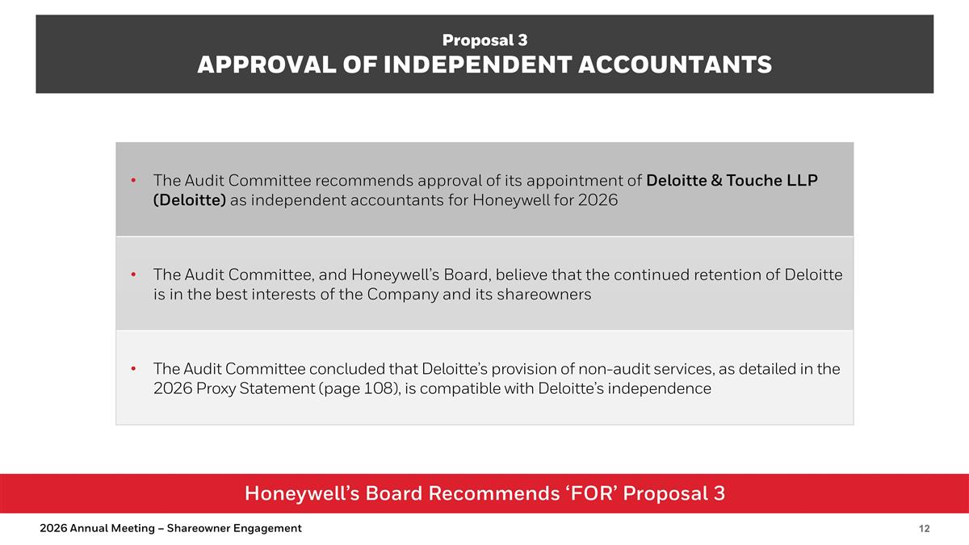
Honeywell’s Board Recommends ‘FOR’ Proposal 3 Proposal 3 Approval of independent accountants The Audit Committee recommends approval of its appointment of Deloitte & Touche LLP (Deloitte) as independent accountants for Honeywell for 2026 The Audit Committee, and Honeywell’s Board, believe that the continued retention of Deloitte is in the best interests of the Company and its shareowners The Audit Committee concluded that Deloitte’s provision of non-audit services, as detailed in the 2026 Proxy Statement (page 108), is compatible with Deloitte’s independence 2026 Annual Meeting – Shareowner Engagement

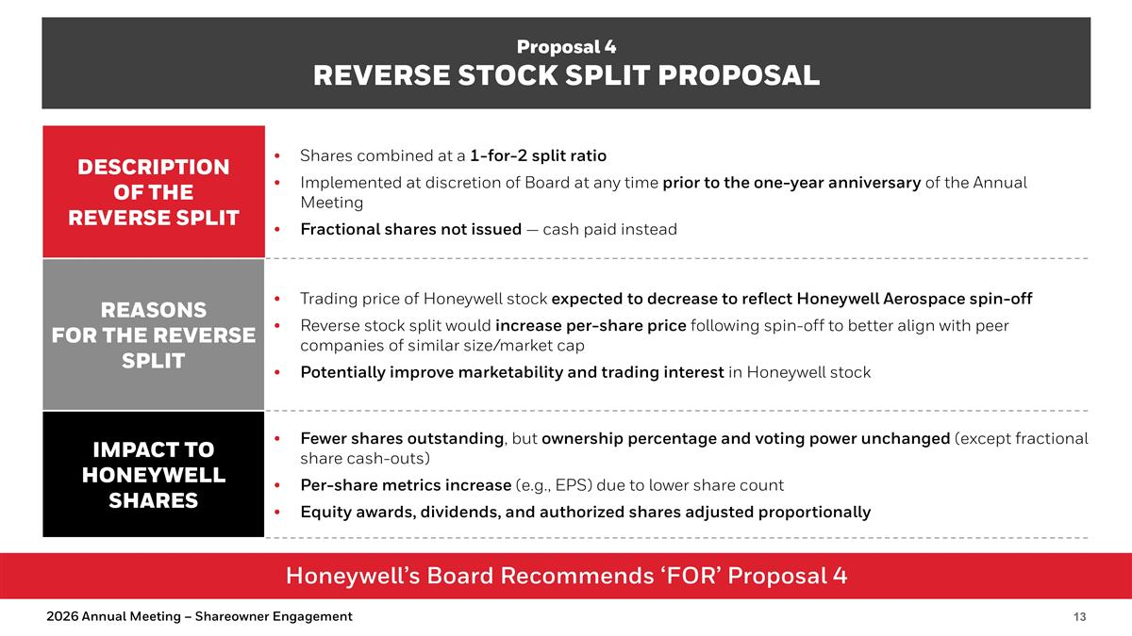
Honeywell’s Board Recommends ‘FOR’ Proposal 4 Proposal 4 REVERSE STOCK SPLIT PROPOSAL Description of the REversE Split Shares combined at a 1-for-2 split ratio Implemented at discretion of Board at any time prior to the one-year anniversary of the Annual Meeting Fractional shares not issued — cash paid instead Reasons for the REVERSE SPLIT Trading price of Honeywell stock expected to decrease to reflect Honeywell Aerospace spin-off Reverse stock split would increase per-share price following spin-off to better align with peer companies of similar size/market cap Potentially improve marketability and trading interest in Honeywell stock Impact to Honeywell Shares Fewer shares outstanding, but ownership percentage and voting power unchanged (except fractional share cash-outs) Per-share metrics increase (e.g., EPS) due to lower share count Equity awards, dividends, and authorized shares adjusted proportionally 2026 Annual Meeting – Shareowner Engagement

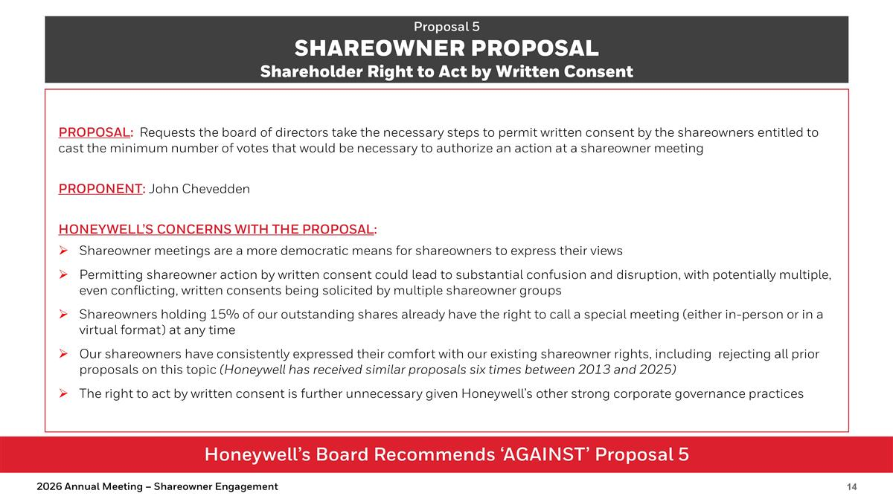
Honeywell’s Board Recommends ‘AGAINST’ Proposal 5 Proposal 5 SHAREOWNER PROPOSAL Shareholder Right to Act by Written Consent PROPOSAL: Requests the board of directors take the necessary steps to permit written consent by the shareowners entitled to cast the minimum number of votes that would be necessary to authorize an action at a shareowner meeting PROPONENT: John Chevedden HONEYWELL’S CONCERNS WITH THE PROPOSAL: Shareowner meetings are a more democratic means for shareowners to express their views Permitting shareowner action by written consent could lead to substantial confusion and disruption, with potentially multiple, even conflicting, written consents being solicited by multiple shareowner groups Shareowners holding 15% of our outstanding shares already have the right to call a special meeting (either in-person or in a virtual format) at any time Our shareowners have consistently expressed their comfort with our existing shareowner rights, including rejecting all prior proposals on this topic (Honeywell has received similar proposals six times between 2013 and 2025) The right to act by written consent is further unnecessary given Honeywell’s other strong corporate governance practices 2026 Annual Meeting – Shareowner Engagement


appendix 2026 Annual Meeting – Shareowner Engagement

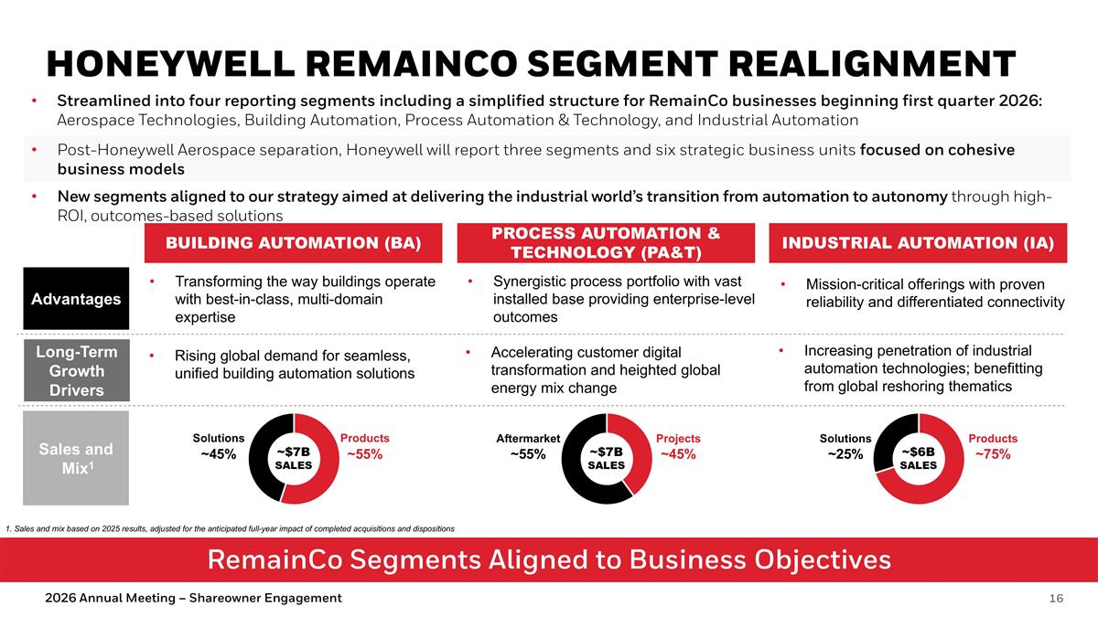
RemainCo Segments Aligned to Business Objectives HONEYWELL REMAINCO SEGMENT REALIGNMENT BUILDING AUTOMATION (BA) PROCESS AUTOMATION & TECHNOLOGY (PA&T) INDUSTRIAL AUTOMATION (IA) Mission-critical offerings with proven reliability and differentiated connectivity Transforming the way buildings operate with best-in-class, multi-domain expertise Synergistic process portfolio with vast installed base providing enterprise-level outcomes Advantages Long-Term Growth Drivers Rising global demand for seamless, unified building automation solutions Accelerating customer digital transformation and heighted global energy mix change Increasing penetration of industrial automation technologies; benefitting from global reshoring thematics Products Solutions Projects Aftermarket Products Solutions ~$7B SALES Streamlined into four reporting segments including a simplified structure for RemainCo businesses beginning first quarter 2026: Aerospace Technologies, Building Automation, Process Automation & Technology, and Industrial Automation Post-Honeywell Aerospace separation, Honeywell will report three segments and six strategic business units focused on cohesive business models New segments aligned to our strategy aimed at delivering the industrial world’s transition from automation to autonomy through high-ROI, outcomes-based solutions Sales and Mix1 ~$7B SALES ~$6B SALES ~55% ~45% ~45% ~55% ~75% ~25% 2026 Annual Meeting – Shareowner Engagement 1. Sales and mix based on 2025 results, adjusted for the anticipated full-year impact of completed acquisitions and dispositions


2025 Annual Meeting – Shareowner Engagement

